
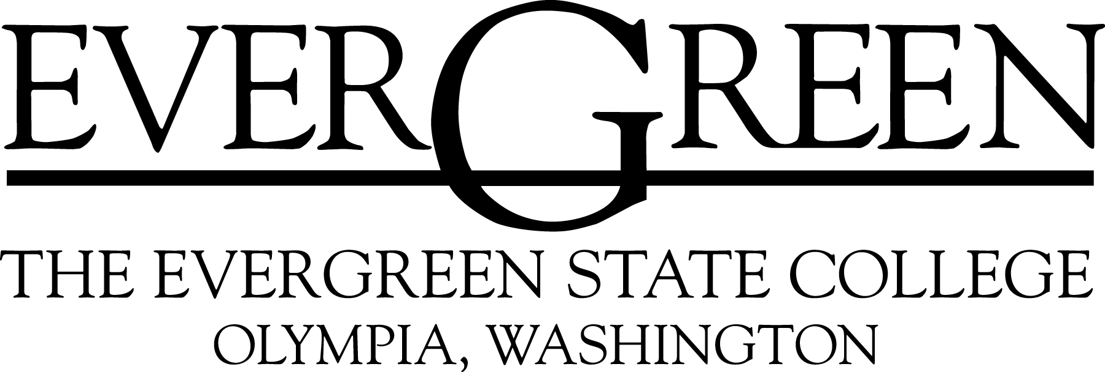
Dual Enrollment with
Central Washington University
For University Center Programs



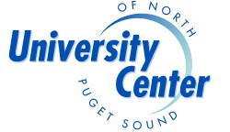
Dual Admission enables you to plan your university transfer program with more certainty.

CWU provides a path to your enrollment at one of CWU’s University Center programs, such as the bachelor’s degree programs on EvCC’s campus or in Lynnwood.

You are eligible to apply for Dual Admission if you:
- Are enrolled at EvCC in a transferable associate degree program (AAS, AS, AB, AAS-T, ATA), and
- You plan to meet CWU’s admission criteria, found at www.cwu.edu/admissions, and
- You have earned fewer than 60 quarter hours of credit.

This program is not applicable to enrollment at the main campus in Ellensburg.

CWU University Center Programs:

- B.S. Interdisciplinary Studies/Social Science (IDS) (offered in Everett and Mt Vernon)

- B.A.S. Information Technology and Administrative Management (ITAM) with specializations in
  - Information Technology
  - Administrative Management

- Go to www.uceverett.org for program information

- More degree programs in Lynnwood. Go to http://www.cwu.edu/lynnwood/index.html

Submit this Inquiry Form to the University Center Office, Gray Wolf Hall,
at Everett Community College

I wish to participate in the Dual Admission program with

□ The Evergreen State College

□ Central Washington University – University Center programs

I understand the qualifications. Please contact me for an appointment.

Print Your Name: ___________________________________________________________________

Signature: ______________________________________________________Date: ______________

Address: _________________________________________________________________________

Phone Number: ______________________________ E-Mail: ________________________________

My signature is my permission for EvCC/University Center advisors to inform CWU or Evergreen of my interest.

Signature: _______________________________________ Date: ______________________

Here’s How It Works:

FIRST YEAR:

- Enroll at EvCC.
2. Meet with your EvCC advisor to discuss your educational plans. If your plans include the option of enrolling in one of CWU’s degree programs at a University Center submit the inquiry form to the right.

END OF YOUR FIRST YEAR:

3. Submit the form at the right to the University Center in Gray Wolf Hall. Meet with a University Center advisor to start the process.

Dual Admission

Make Your Path
Toward a
Bachelor’s Degree

Start Your Education at
Everett Community College
&
Complete Your
Bachelor’s Degree at

Central Washington University

or

The Evergreen State College

Dual Admission with Evergreen

Admitted to Everett Community College AND The Evergreen State College

Got questions about starting college?

2000 Tower Street
Everett WA 98201
Call 425-388-9219
or send e-mail to
admissions@everettcc.edu

earning your bachelor’s degree?

Smoooooooth

University Center, Gray Wolf Hall
2000 Tower Street
Everett WA 98201
425-259-8900
www.uceverett.org
Everett Community College does not discriminate on the basis of race, religion, creed, color, national origin, age, sex, marital status, disability, or veteran status.

G reg.com.dir.dual enr bro
Dept Share: University Center: Articulation Agreements: dual enro.broch
Got questions about earning your bachelor’s degree in Everett?
During your first year at Everett Community College, you may apply for Dual Admission to The Evergreen State College.
Your first two years of community college coursework will have more relevance when you transfer if you work closely with both your community college and Evergreen advisors from the first. The Dual Admission program establishes a process and priority for you to assure yourself a smooth transfer to Evergreen.
Please read the qualifications below. Then complete the inquiry form inside this brochure to the University Center in Gray Wolf Hall to start the process.

Programs at Evergreen:
Agriculture – Sustainable
Arts – Fine, Visual and Performing Arts
Biological Sciences
Business/Management
Communications
Computer Science
Environmental Studies
Film and Video
Humanities
International Studies
Languages
Marine Studies
Physical Sciences
Social Sciences
And more….
Evergreen currently offers a B.A. in Liberal Arts (Reservation Based) at Tulalip
www.evergreen.edu

Qualifications for Dual Admission:
- Toward the end of your first 45 college credits, complete the form on the reverse side and submit it to the University Center in Gray Wolf Hall. Provide permission for Everett CC to transmit your request to participate in Dual Admission to Evergreen.
- Maintain contact with an Evergreen Advisor who will be assigned to you by Evergreen.
- To meet the terms of regular admission to Evergreen at the time you plan to enroll, you must demonstrate:
  - Minimum GPA of 2.5 earned at Everett CC.
  - Satisfactory progress; no more than 5 W, I, and V grades.
  - Completion of AAS-DTA, AB or AS degree, completion of an ATA or AFA degree covered by the Upside Down agreement, or 90 transferable credits of specifically negotiated coursework.
- Actual enrollment at Evergreen within 6 months of completing your coursework. Submit application for regular admission to Evergreen, with required final transcript at least 3 months prior to intended enrollment. (Evergreen waives the application fee if all parts of these criteria are met.)

