Marketing Your Class
Direct communication from subject area experts and peers is the most impactful way to encourage enrollments.
In addition to the many ways that we market your programs, we have several tools and resources available to help you at www.everettcc.edu/ccecinstructors
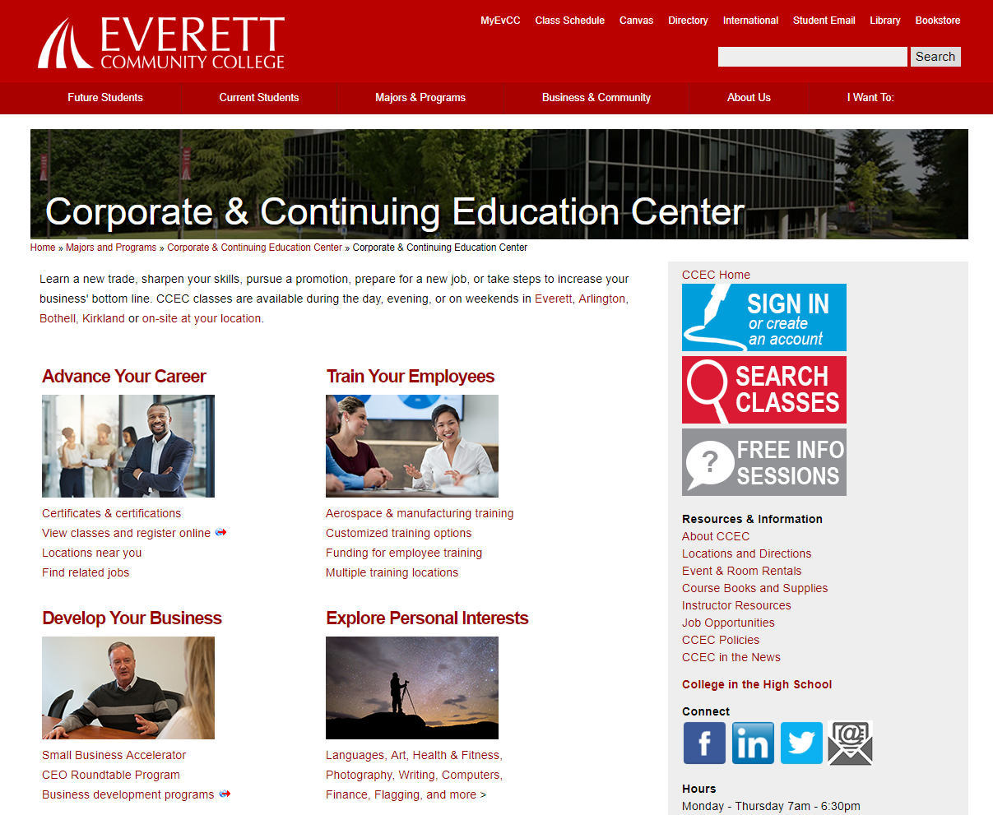
- Flyer templates – Plug in your course information with our provided templates.
  - Creating your own flyer? Please talk with your program manager about the required EvCC logo and abbreviated nondiscrimination statement.
- We have social media accounts on Facebook, Twitter, and LinkedIn. We’d love to share out your articles, stories, photos, or videos. Tag us in your posts, post to our pages, or reply to our posts. Encourage your students to engage on social media – maybe they can share their thoughts about a subject using a unique hashtag or on a blog. Then tell us about it so we can share out their stories!
- Take photos or video in your class. Are your students working on a particularly fun visual exercise? Capture it and share it out. Download photo release forms from the website.
- We have a monthly newsletter with the potential to reach up to 30,000 people across the Puget Sound! Write a short article for us about industry trends, tips or success stories. Send your story ideas to lijones@everettcc.edu.
If you are promoting your class in other ways, let us know. We can help you spread the word.

